|  |
| --- |
|  |
| Capstone Project Document |

**VIETNAMESE STUDY SYSTEM FOR JAPANESE**

Report #1 - User Requirement Specification

|  |  |
| --- | --- |
| **Vietnamese Study System For Japanese** | |
| **Group Members** | Nguyễn Ngọc Minh |
| Nguyễn Trọng Duy |
| Nguyễn Hoàng Linh |
| Đào Thanh Tùng |
| Nguyễn Hồng Quân |
| Phạm Đức Thắng |
| **Supervisor** | Mr. Nguyễn Văn Sang |
| **Project code** | Veazy |

**- Hanoi, 07/2016 –**

# SIGNATURE PAGE

AUTHOR: Nguyễn Hồng Quân 31/07/2016

Team member

REVIEWERS: Nguyễn Ngọc Minh --/--/--16

Project manager

APPROVAL: Nguyễn Văn Sang --/--/--16

Supervisor

Record of change

*A - Added M - Modified D – Deleted

|  |  |  |  |  |  |
| --- | --- | --- | --- | --- | --- |
| Effective Date | Changed Item | A,M,D | Change Description | Reason for Change | Rev. Number |
| 31/Jul/2016 | Create User Requirement Specification | A | First version | Create User Requirement Specification | 1.0 |
|  |  |  |  |  |  |
|  |  |  |  |  |  |
|  |  |  |  |  |  |
|  |  |  |  |  |  |
|  |  |  |  |  |  |
|  |  |  |  |  |  |
|  |  |  |  |  |  |
|  |  |  |  |  |  |
|  |  |  |  |  |  |
|  |  |  |  |  |  |
|  |  |  |  |  |  |
|  |  |  |  |  |  |
|  |  |  |  |  |  |
|  |  |  |  |  |  |
|  |  |  |  |  |  |
|  |  |  |  |  |  |

Contents

SIGNATURE PAGE 1

1 USER REQUIREMENTS SPECIFICATION 3

1.1 Introduction 3

1.1.1 Purpose 3

1.1.2 Definition and Acronyms 3

1.2 Overall Description 3

1.2.1 Business Process Overview 3

1.2.2 Product Features 20

1.2.3 User characteristic 21

1.3 Functional Requirements 22

1.3.1 View Lesson 22

1.3.2 Searching Lesson 22

1.3.3 Dictionary 22

1.3.4 Testing 22

1.3.5 Management Profile 22

1.3.6 Add new lesson 23

1.3.7 Edit lesson 23

1.3.8 Delete lesson 23

1.3.9 Add new question 23

1.3.10 Edit question 23

1.3.11 Delete question 23

1.3.12 View report 24

1.3.13 System Statistic 24

1.3.14 Management user 24

1.4 Non-functional Requirement 24

# USER REQUIREMENTS SPECIFICATION

## Introduction

### Purpose

This document will provide the describing of general requirement and non-functional requirements of our Veazy system. It also describes the requirement scope of each phase in the project.

### Definition and Acronyms

|  |  |
| --- | --- |
| Terms | Description |
| Veazy | Vietnamese Study System For Japanese |
| GUI | Graphical User Interface |

**Table 1-1:** Definition and Acronyms

## Overall Description

### Business Process Overview

Veazy is an e-learning website. Therefore, that system will implement the following processes:

#### Register workflow

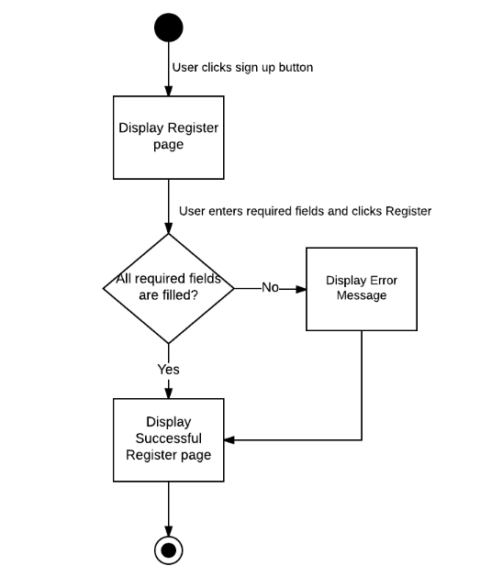

Brief description: Guest can use this function. Steps:

* Step 1: User clicks on Sign Up button.
* Step 2: System display Sign Up page.
* Step 3: User enters required fields and clicks on Register button.
* Step 4: System display Successful Register page or Error Message.

#### Login workflow

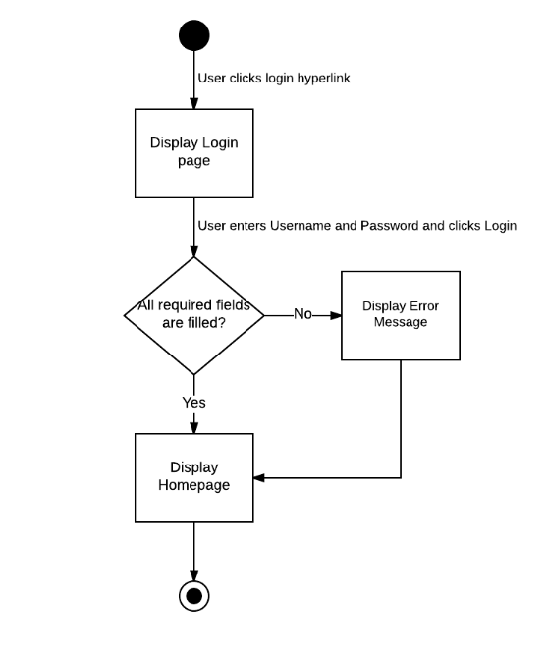

Brief description: Guest can use this function. Steps:

* Step 1: User clicks on Login hyperlink.
* Step 2: System display Login page.
* Step 3: User enters Username and Password and clicks on Login button.
* Step 4: System display Homepage or Error Message.

#### Forgot Password workflow

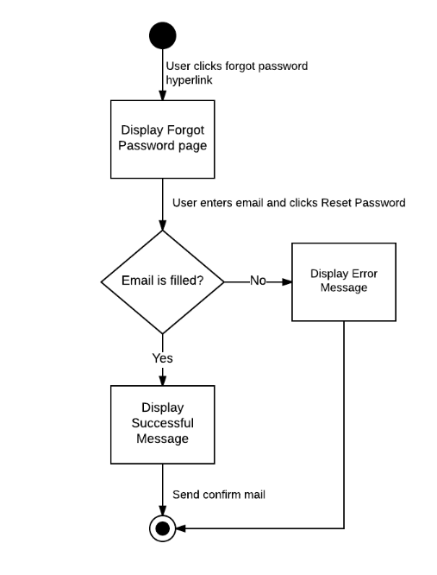

Brief description: Guest can use this function. Steps:

* Step 1: User clicks on Forgot Password hyperlink.
* Step 2: System display Forgot Password popup.
* Step 3: User enters email and clicks on Reset Password button.
* Step 4: System display Successful Message or Error Message.

#### Search workflow

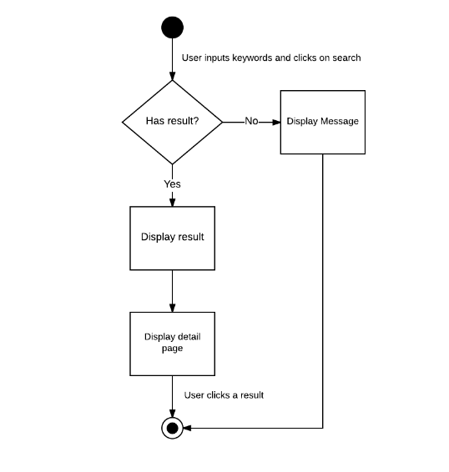

Brief description: Guest and Member can use this function. Steps:

* Step 1: User inputs keywords into search textbox and clicks on Search button.
* Step 2: System return search results or message if nothing found.
* Step 3: User can click returned results to view detail.

#### Study workflow

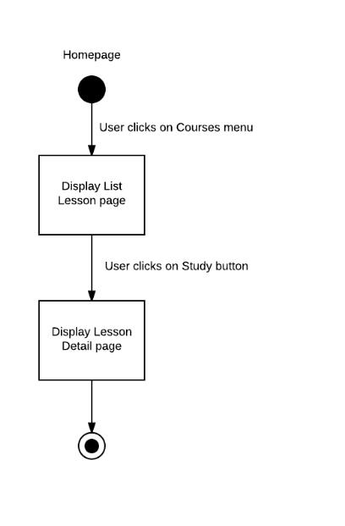

Brief description: Guest and Member can use this function. Steps:

* Step 1: User clicks on Courses menu.
* Step 2: System display List Lesson page.
* Step 3: User clicks on Study button.
* Step 4: System display Lesson Detail page.

#### Testing workflow

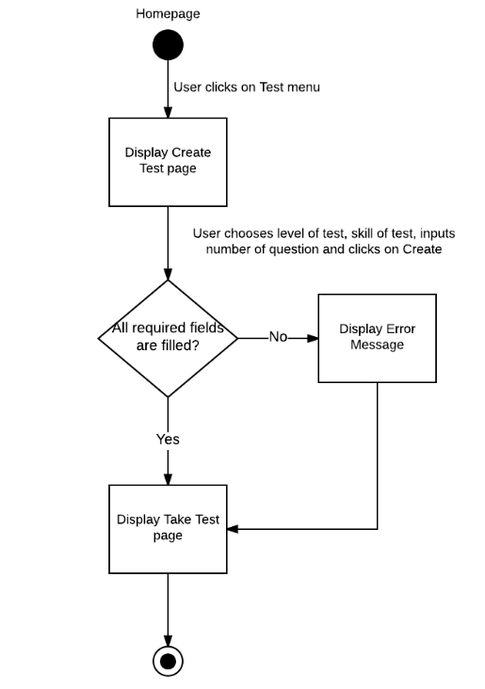

Brief description: Guest and Member can use this function. Steps:

* Step 1: User clicks on Test menu.
* Step 2: System display Create Test page.
* Step 3: User chooses level of test, skill test, and number of questions.
* Step 4: User clicks on Create button.
* Step 5: System display Take Test page.

#### Add Lesson workflow

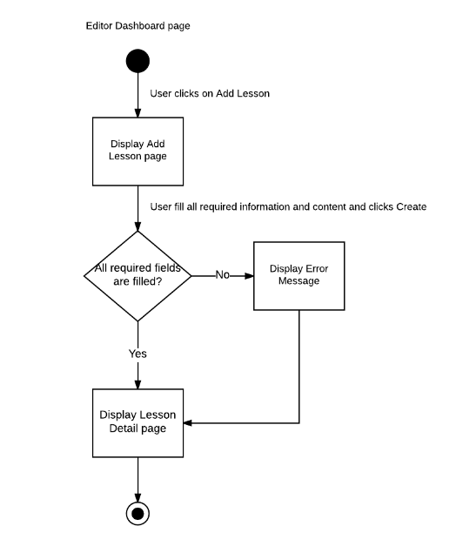

Brief description: Content Editor can use this function. Steps:

* Step 1: Content Editor clicks on Add Lesson in Lesson menu.
* Step 2: System display Add Lesson page..
* Step 3: Content Editor fills all required information and content of lesson and clicks on Create button.
* Step 4: System display Lesson Detail page or Error Message.

#### Add Question workflow

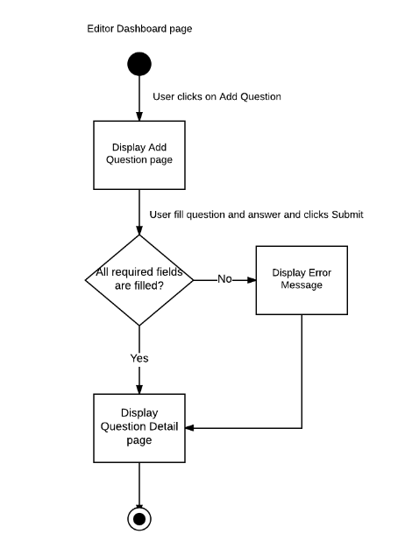

Brief description: Content Editor can use this function. Steps:

* Step 1: Content Editor clicks on Add Question in Question menu.
* Step 2: System display Add Question page..
* Step 3: Content Editor fills question and answer of question and clicks on Submit button.
* Step 4: System display Question Detail page or Error Message.

#### Report Content workflow

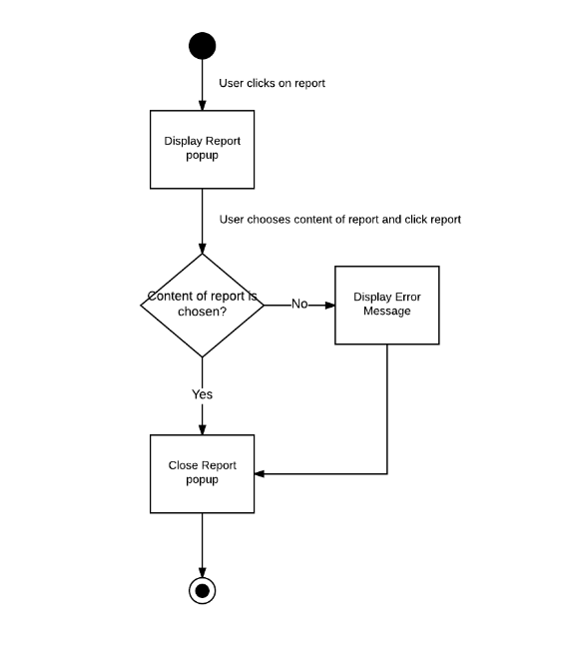

Brief description: Member can use this function. Steps:

* Step 1: Member clicks on Report button.
* Step 2: System display Report popup.
* Step 3: Member chooses content of report and clicks on Report.
* Step 4: System close Report popup or Error Message.

#### Ban/Unban user workflow

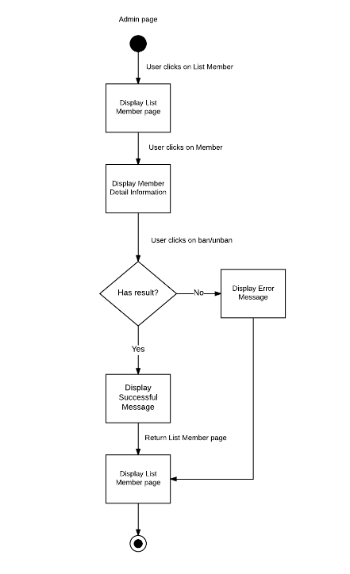

Brief description: Administrator can use this function. Steps:

* Step 1: Administrator clicks on List Member menu.
* Step 2: System display List Member page.
* Step 3: Administrator clicks on Member who Administrator want to ban/unban.
* Step 4: System display Member Detail Information page.
* Step 5: Administrator clicks on Ban/Unban button.
* Step 6: System display Successful Message or Error Message.
* Step 7: System display List Member page.

### Product Features

Veazy is a website, user only connect to internet to use website. System provides these main functions:

#### Guest features

* **Register:** User can register new account and login to use all features of Veazy.
* **Login:** User login to Veazy system.
* **Search:** User can search lessons, words and system will display all of result related to keywords.
* **Forgot Password:** If user forgot their password, user can send a request to reset their password.
* **Learning:** User can learn Vietnamese through lessons of system.
* **Testing**: User can take a multiple-choice test and view result at the end of test.

#### Member features

* **Management Profile:** System just allows user who logins as Member can manage their profile such as view their information, update their information, change new password, as well as view their statistical learning process.
* **Report Content:** System just allows user as Member can send a report to Content Editor about wrong content of lesson or question.
* **Retake Test:** System just allows user as Member can view their list test history, review test and retake test.

#### Content Editor features

* **Management Profile:** When user logins as a Content Editor, user can manage their profile such as view Content Editor information, update information and change password.
* **Manage Lesson:** When user logins as a Content Editor, user can manage lesson of system. So that user can view all lesson of system, search, add new lesson, edit or delete lesson.
* **Manage Question:** When user logins as a Content Editor, user can manage question of system. So that user can view all question of system, search, add new question, edit or delete question.
* **View Report:** System’s Member send reports about wrong content of lesson or question. Content Editor can view this reports to determined that the content is wrong or not and edit it.

#### Admin features

* **Management Profile:** When user logins as a Admin, user can manage their profile such as view Admin information and change password.
* **Manage user:** When user logins as a Admin, user can manage member of system as: view list member of system, view detail information, ban/unban member or set permission for member.
* **System statistics :** When user logins as a Admin, user can view statistics of system.

### User characteristic

Veazy requires users to have the ability to use a browser with an internet connection. If users want to use all function, they must be login.

There are 4 main actors that system support:

* **Guest:** User doesn’t login to system, they can use the basic functions of website as: dictionary, learning via lesson and take test.
* **Member:** Have account on system, they can access basic functions of guests and manage profile, redo recently taken tests and view statistics of abilities based on those taken tests.
* **Content Editor:**  They can manage website content which includes lessons, test question.
* **Administrator:** They can manage user’s i.e checking user detailed information, set permission and ban/unban.

## Functional Requirements

### View Lesson

**Access right: Guest and member**

This function is used to view an lesson. The system will display a detail lesson page for user. In this screen, user can view detail content of lesson as Vocabulary, Grammar, Conversation, Listening, Reading and Practice. If user logins as a Member, they can send a report to Content Editor that contents of this lesson are wrong.

### Searching Lesson

**Access right: Guest and member**

This function is used to search lesson. User enters keywords into search box and system will display results of searching for user. In this screen, user click on each lesson to view detail lesson page.

### Dictionary

**Access right: Guest and member**

This function is used to search word. User enters keywords into search box and system will display results of searching for user. In this screen, user can view results of word and their meaning.

### Testing

**Access right: Guest and member**

This function is used to take a multiple-choice test. User chooses level, skill of test, and enters number of question and system will display taking test page for user. In this screen, user can take test and view result at the end of the test. If user logins as Member, user can report questions of the test and view list history test, as well as retake test.

### Management Profile

**Access right: Member, Content Editor, Administrator**

This function is used to view detail personal information. User click on their account and system will display profile page for user. In this screen, user can view their profile, update their profile and change their password. If user logins as Member, user can view statistics about their learning process. If user logins as Administrator, user just view their profile and change password.

### Add new lesson

**Access right: Content Editor**

This function is used to add new lesson for course. The system will display add lesson page for user. In this screen, user fills all required field and contents of lesson and clicks on Create to add lesson, clicks on Save Draft to save lesson or clicks on cancel to cancel adding lesson.

### Edit lesson

**Access right: Content Editor**

This function is used to edit lesson of course. The system will display edit lesson page for user. In this screen, user update all field and contents of lesson and clicks on Update to edit lesson, clicks on Save Draft to save lesson or clicks on cancel to cancel Editing lesson.

### Delete lesson

**Access right: Content Editor**

This function is used to delete lesson out of system. The system will show caution that user want to delete this lesson or not. User clicks on Yes to delete this lesson or No to cancel deleting lesson.

### Add new question

**Access right: Content Editor**

This function is used to add new question. The system will display add question page for user. In this screen, user fills all required field (content and answer) of question and clicks on Create to add question, clicks on Save Draft to save question or clicks on cancel to cancel adding question.

### Edit question

This function is used to edit question. The system will display edit question page for user. In this screen, user update content and answer of question and clicks on Update to edit question, clicks on Save Draft to save question or clicks on cancel to cancel Editing question.

### Delete question

**Access right: Content Editor**

This function is used to delete question out of system. The system will show caution that user want to delete this question or not. User clicks on Yes to delete this question or No to cancel deleting question.

### View report

**Access right: Content Editor**

This function is used to view list report from system’s member. The system will display list report page for user. User can view content of report in list report.

### System Statistic

**Access right: Administrator**

This function is used to view statistic of system. The system will display statistic page for user. User can view all statistic of system in this page.

### Management user

**Access right: Administrator**

This function is used to manage member of system. The system will display list member page for user. User clicks on each member to view detail information of member. In this screen, user can ban/unban member or set permission for member.

## Non-functional Requirement

The system has to satisfy these principles:

* **GUI:** The user interface must be clear, friendly and easy to use**.**
* **Visibility**: Important information (example: text in nodes) should be clearly visible.
* **Easy to maintain and upgrade**
* **Ensure data security capabilities, high performance**
* **Scalability system**